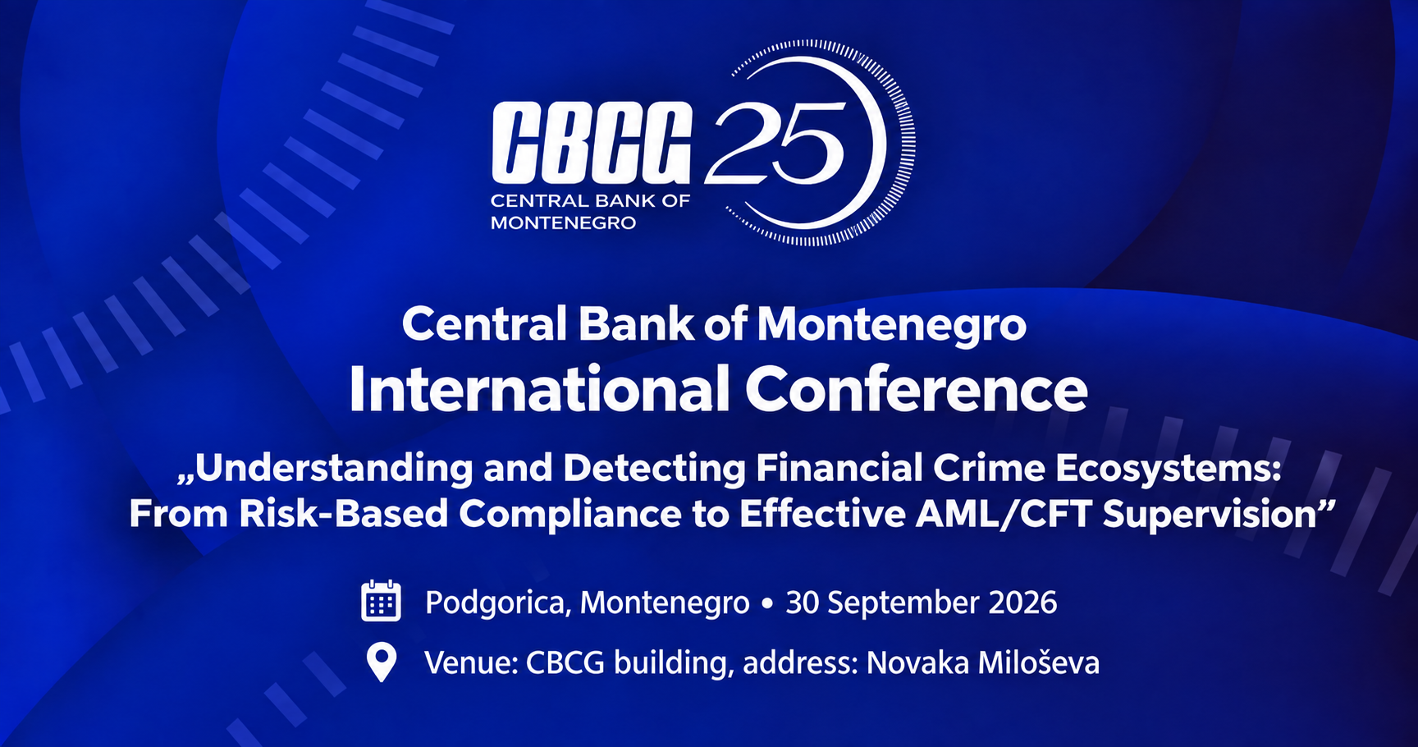
AGENDA
Wednesday, 30 September 2026
09:30 – 10:00 | Registration and Welcome Coffee
10:00 – 10:10 | Opening Remarks  - Irena Radović - Governor, Central Bank of Montenegro
10:10 – 10:20 | Group Photo (for all participants)
10:20 – 10:35 | Expert Presentation - Following the Influence: PEPs, Corruption Networks and the Financial Crime Ecosystem  - Drago Kos - Dean and Executive Secretary, International Anti-Corruption Academy
10:35 – 11:25 | PANEL I  “Building a Resilient Financial Crime Prevention Ecosystem: Standards, Integrity and Cooperation’’  Moderator: Danijela Lasica - Journalist and News Editor, TV Vijesti  Panelists:  - Dominik Vu - Head of Executive Bureau with coordination of International and Interinstitutional Relations, AMLA  - Lorena Ungureanu - Programme Manager, MONEYVAL - Council of Europe  - Drago Kos - Dean and Executive Secretary, International Anti-Corruption Academy  - Michel Carles - International Expert in fighting corruption, money laundering, financing crime, tax fraud
11:25 – 11:40 | Expert Presentation - From Compliance to Effectiveness: Understanding Financial Crime Ecosystems Through the MONEYVAL Lens  - Lorena Ungureanu - Programme Manager, MONEYVAL - Council of Europe
11:40 – 11:55 | Expert Presentation - AMLA and the Future of AML/CFT: Building a Single European Response to Financial Crime  - Dominik Vu - Head of Executive Bureau with coordination of International and Interinstitutional Relations, AMLA
11:55 – 12:40 | Lunch
12:40 – 12:55 | Expert Presentation - Regulatory and Legal Framework - What Legislative and Judicial Changes Mean for Supervisory Authorities  - Michel Carles - International Expert in fighting corruption, money laundering, financing crime, tax fraud
12:55 – 13:55 | PANEL II  “Bridging Regulatory Expectations and Supervisory Practice: Experiences in AML/CFT Risk-Based Supervision”  Moderator: Marina Mićunović - Senior Programme Officer, Council of Europe Programme Office in Podgorica  Panelists:  - Gordana Kalezić - Vice-Governor,Central Bank of Montenegro  - Rigert Jata - Head of Unit for Licensing and Supervision of FEOs, Supervision Department, Bank of Albania  - Vesna Krizmanić - Director, Directorate for Supervision of the Prevention of Money Laundering and Terrorist Financing, Croatian National Bank  - Rudmer Van Der Meulen - Principal Supervisor, De Nederlandsche Bank  - Iskra Ivanovska-Stojanovska - Senior Advisor, On-Site Supervision Department, National Bank of the Republic of North Macedonia
13:55 – 14:05 | Interactive Q&A Session “Ask the Experts”
14:05 – 14:10 | Closing Remarks  - Gordana Kalezić, Vice-Governor, Central Bank of Montenegro

